***Research and development support for   
new music projects***

**GUIDELINES AND INFORMATION**

**WHO WE ARE:**

Sound UK brings music creators and the public together to experience extraordinary music nationwide.

We have a strong track record in delivering high quality, distinctive projects in any setting - from major arts centres to grass roots venues, villages to major cities, beaches to online.

From National Trust to Barbican Centre, we have collaborated with over 100 leading organisations.

We’ve given almost 150,000 people from Cornwall to Hull the opportunity to experience exceptional new music. Since 2001 we’ve supported over 300 of the world’s most original music creators of all genres through more than 100 acclaimed national projects.  
  
Our projects bring excellent music to diverse audiences and explore wider issues, such as the environment, social justice and health.

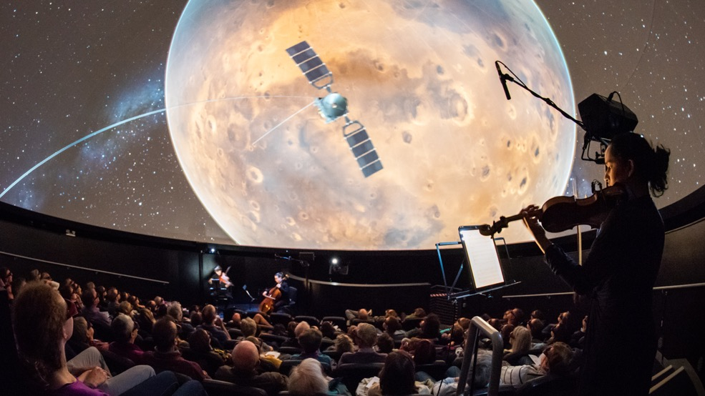

*The Planets, We The Curious c Lee Pullen*

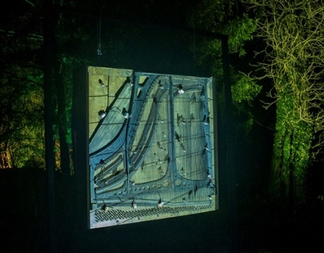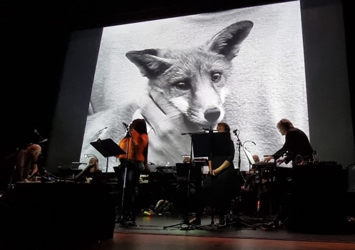

Kathy Hinde Piano Migrations - Alight

Arcadia Live

**WHAT IS SOUND GENERATOR?**

Now in its fourth year, **Sound Generator** is a **research and development** (R & D) programme that supports artists and seeds the development of an ambitious new project.

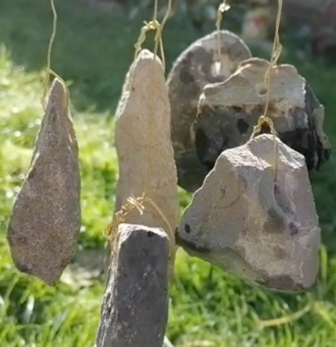

*‘Rock Wind Chime’ prototype   
- Andrew Woodhead*

Each year six early career music and sound artists spend six months developing and testing their project, supported by mentoring from a range of experts.

By the end of the programme artists will have thoroughly explored their initial idea and tested that they can make it work, ready for the next stage of full commissioning and public engagement.

During the process artists will be able to try out new approaches, learn from others, increase their network and develop their practice.

**Projects can be:**

* For indoors or outdoors
* Suitable for venue touring or site specific
* Digital, installation or live
* Music, sound or multi-disciplinary
* Designed to reach a new audience, work with a specific community or respond to the world we live in.

Following an open call, six artists will each receive an award of £2500 to research and develop their idea across six months (October 2024 to March 2025).   
  
In addition to £2500, the programme includes access to the Sound Generator Network with support sessions from a range of exceptional mentors, plus opportunities to connect with other artists on the programme.  
  
The R & D will culminate in the creation of a short audio or video sample of the project, and a project outline / proposal for its delivery. These will be presented by each artist at an internal sharing at the end of the programme and sent out to a wide network of industry contacts.

**WHO IS IT FOR?**

* UK* creators that reflect the population of the UK
* Creators with **5 – 10 years professional experience**
* Creators who want to develop a new idea that extends their practice, with a public outcome in mind.
* Artists pushing the boundaries of music. Working within, but not exclusively, jazz, sound, folk, contemporary classical and electronic music, plus all points in between.

*we define a UK artist as someone who has been based and working in the UK for more than 5 years.

**WHAT ARE WE LOOKING TO SUPPORT?**

We’re looking to support the research and development of artists and ideas:

* that demonstrate ambition and quality
* in a range of formats including live, digital, installation (**excluding album recordings**)
* that extend artistic practice and discipline (e.g. extending your craft/genre, using new tech, interdisciplinary work)
* suitable for a variety of settings and locations, arts and non-arts
* address public engagement or participation
* that seek to reach a diverse audience or focus on reaching a particular target audience e.g. young people
* that might impact the way we think or feel e.g. about the environment, social issues, or our own / others wellbeing

**We are NOT looking to support:**

* Projects that already exist
* Album recordings
* Artists with more than 10 years’ professional experience

You can meet the meet our previous Sound Generator artists here:   
[2023](https://www.sounduk.net/events/sound-generator-artists-2023/) | [2022](https://www.sounduk.net/events/sound-generator-artists-2022/) | [2021](https://www.sounduk.net/events/sound-generator-artists-2021/)

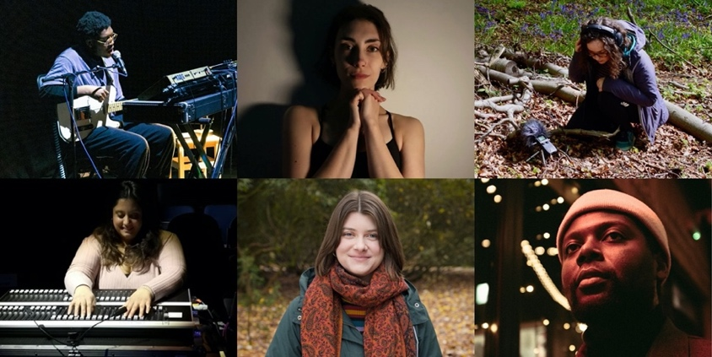

Sound Generator 2023 Artists

*“This has been so valuable for me, Sound Generator has definitely helped me take my career to the next level. Being able to dedicate time to my craft in this focussed way alongside the amazing mentorship has done wonders for my confidence moving forward.”***Marco Woolf, Sound Generator artist 2023.**

*“Having access to Sound UK’s networks and the opportunity to connect with incredible artists who are experts in their fields and to receive targeted mentoring from them to support the project has been both inspiring and transformational for my practice.”* **Gwen Siôn, Sound Generator artist 2023**

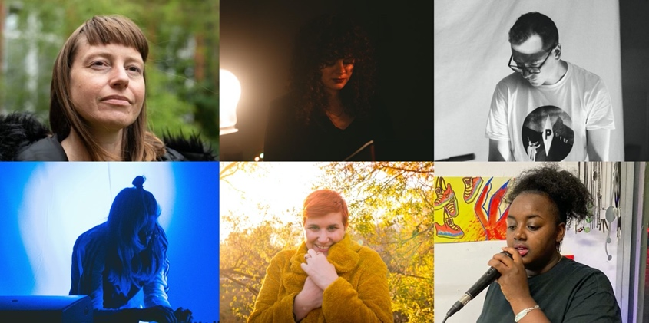

Sound Generator 2022 Artists

*“This opportunity has been so significant in pushing me forward as an artist; to have the funding to allow creative room in realising something so ambitious is a valuable thing.”***Piera Onacko, Sound Generator artist 2022**

*“We learnt so much and mentoring + support was very helpful in furthering our ideas. I think it also puts us in a better position to get further funding and for potential future collaborations.*”  
**Daphnellc & Ambra, Sound Generator 2022** *“Sound Generator was a great experience, I hope the programme continues to give more UK based artists working with sound a chance to experience such a good R&D programme*.”  
**Jordan Edge, Sound Generator 2021**  
  
*“The best thing about the programme was having the time, conversation and mentoring to fully develop and condense a big idea into something that is ready for an audience.”***Lori E. Allen, Sound Generator 2021**  
  
**You can get an idea of the range of work we produce by looking at our** [**past projects**](https://www.sounduk.net/events/#past)**.**

**HOW DOES IT WORK?**

1. **INITIAL MEETING:** One-to-one consultation with Sound UK producers to clarify your idea and R&D needs. Together we will design how best to use the award and identify mentors.
2. **MONTHLY CATCH UPS:** Phone or video callwith your designated Sound UK producer (Maija Handover or Polly Eldridge) to check in on how you’re doing.
3. **ARTIST MEET UPS:** three Sound Generator meet ups with guest speakers e.g. funders or artists. These will be online and in person. They are an opportunity to get to know the other Sound Generator artists, share ideas and learn from each other as well as the guest speaker.
4. **MENTORING:** 10 hours’ support and advice from up to five mentors to help you develop and test your idea. These include:

* high level creative, technical, communication and funding professionals
* programme directors from a range of partners (e.g. venues, heritage organisations and public spaces).

You may want to use that time with just one mentor or across a number of different mentors. The consultation with Sound UK will help decide what will work best for you.

1. **INTERNAL SHARING EVENT & PROJECT DISTRIBUTION:** At the end of the programme, all Sound Generators come together to present their project sample to each other in an internal sharing event. With advice from Sound UK producers, artists create a project outline document which is sent out to Sound UK’s network at the end of the programme.

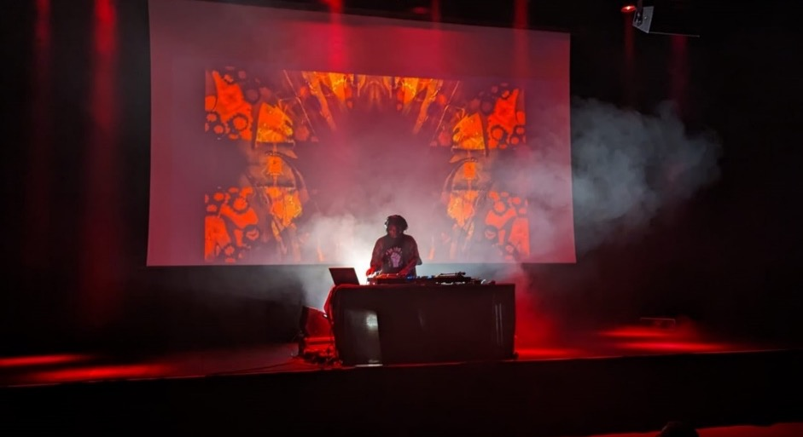

NikNak Sankofa at Kings Place

**HOW CAN AWARDS BE SPENT?**

Sound UK will help each artist decide how best to spend their £2500 award across the 6-month programme.

The award will need to cover your time and any costs to create your idea proposal and audio or visual sample. For example, you might want to buy some software, book a recording or rehearsal studio, employ a wider creative team to try out work in progress or go on site visits.

**We anticipate the majority of the award will go towards your time on the project.**

**PROGRAMME COMMITMENTS**

Each artist will spend their award in different ways but we hope the majority will be spent on your time. For example, if 100% of the award was spent on your time this would be 10 days at £250 per day.

In addition, to benefit from this programme it is important to be able to be able to commit to:

* Monthly one to ones with Sound UK – these are for you so can be as short as 15-30 minutes or up to an hour.
* Cohort meetings – We aim to have three meetings, one near the start, half way through and the internal sharing at the end.

We aim for one meeting and the internal sharing to be in person. We always strive to find a geographically suitable location but artists should allow for travel time.

The online meeting is 90 minutes. The first in person meeting is two hours and the internal sharing is an afternoon into early evening.

* Deadlines– meeting the deadline for delivering a project outline, sample and a draft budget on 20 March 2025 is a compulsory requirement of the programme.

**OUTCOME & OUTPUTS**

Our aim is that each artist will leave the programme with a robust, tested idea ready to be pitched to potential partners and funders to be fully realised.

At the end of 6 months we hope each artist will have developed their creative practice, confidence, skills and contacts.

By the end of the programme each of Sound Generator 24 artist will have created:

* A short project sample (audio / video / visual as appropriate)
* A project outline (word / pdf)

These will be presented at the end of programme internal sharing.

The 2024 programme’s project outlines will also be mailed to Sound UK’s mailing list of promoters, funders and organisations.

All artists will be advised on potential partners to realise their projects after the programme as appropriate.

**HOW DECISIONS WILL BE MADE**

Sound UK producers present a long list to a panel of leading industry figures including a funder, an artist and a venue.

Proposals will be considered against the following criteria:

Eligibility

* Artistic vision and quality
* Track record of creator for creating and delivering original material
* Will a public execution of it be feasible
* Has the audience for the project been considered, and how they will engage / participate

We seek to balance:

* Diversity of creators
* Diversity of music and creative styles
* Geography of creators across the country

**ACCESS**

We are committed to making Sound Generator accessible to all and supporting applicants facing barriers to applying.

If you have any access requirements, require the application form in an alternative format, or need support putting in an application, please contact us at [info@sounduk.net](mailto:info@sounduk.net) and tell us what you need to apply.

**HOW TO APPLY & DEADLINES**

Have a good look at our website to find out more about Sound UK’s work.

Complete the online application form here: [Sound Generator application form](https://forms.gle/gdHe8Aj2f5exPrcW9)

*Please note there are character limits on some of the answers. Please stay within them or your answer may be cut off.*

If you need to apply by video please let us know.

If you have any questions about the form, please email [info@sounduk.net](mailto:info@sounduk.net)

**DEADLINE:** Wednesday 17 July 2024 at 5pm

**AWARD DECISION:**  Thursday 12 September 2024

**DEADLINE FOR SAMPLE, PROJECT OUTLINE & BUDGET:** Thursday 20 March 2025

**END OF PROGRAMME INTERNAL SHARING EVENT:** Thursday 27 March2025